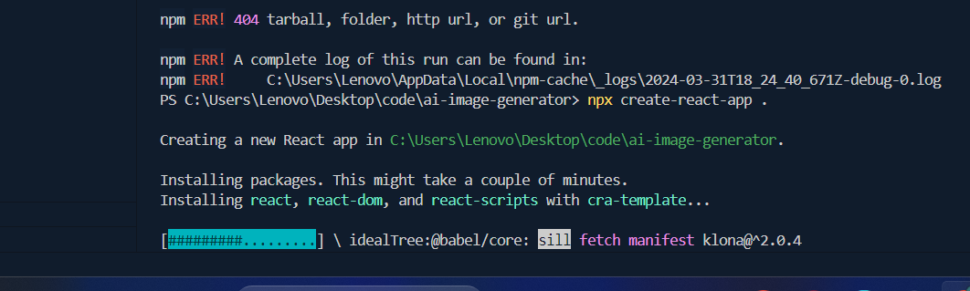Set up

1.Install the react project npx create-react-app .

After that we need to write npm start to run our react app

Done

2.this is the default react app

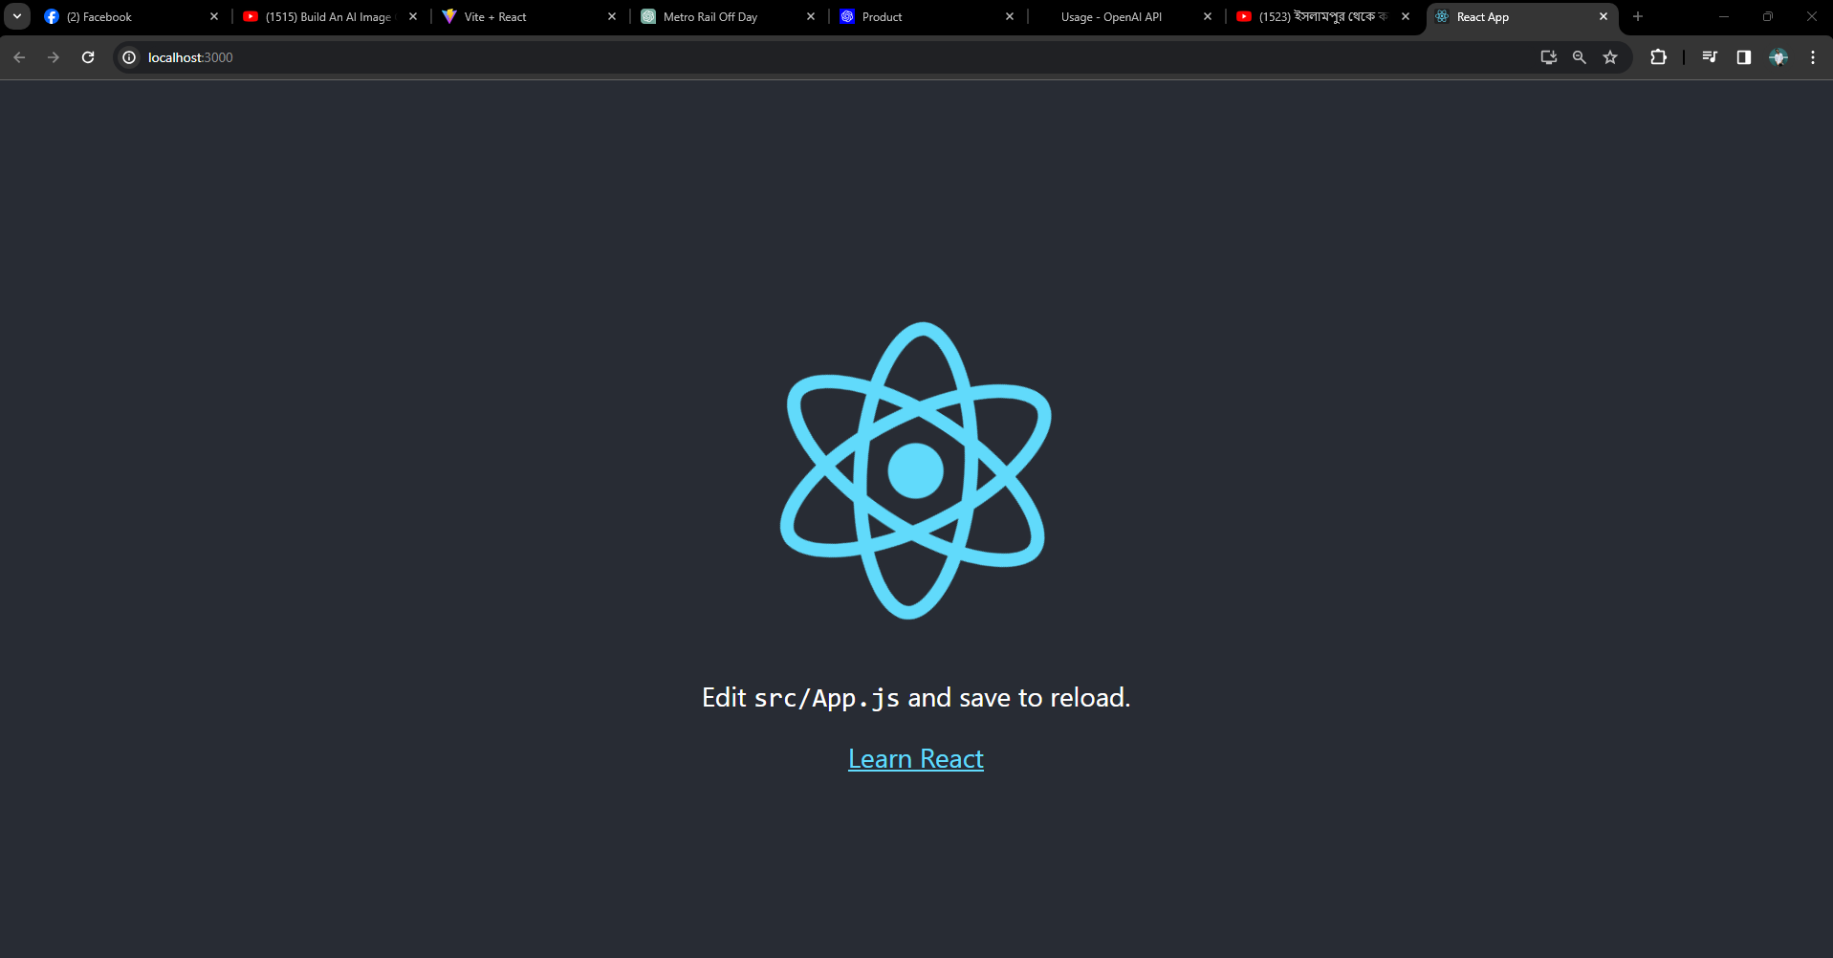

Customize the design

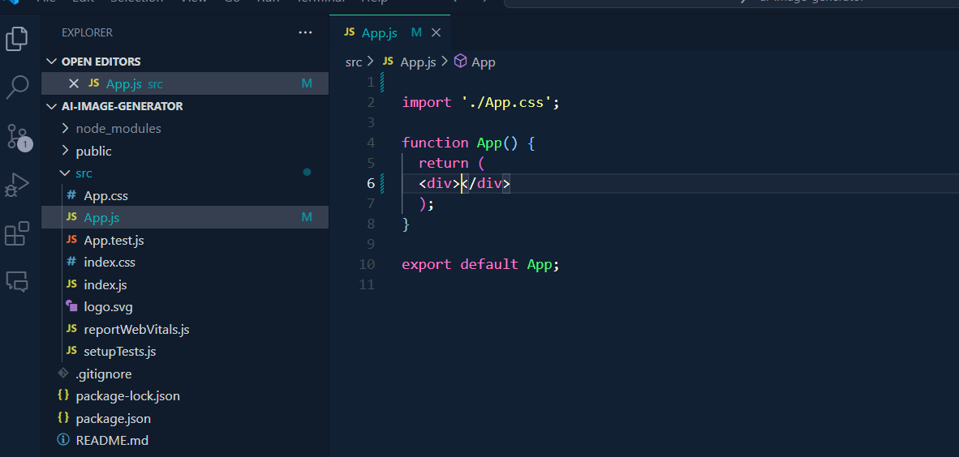

1.remove the old div and import statement

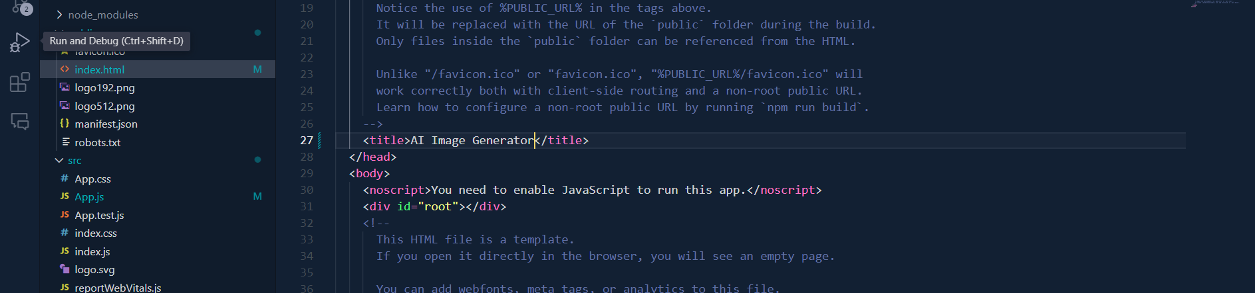

2.index.html er title change korbo

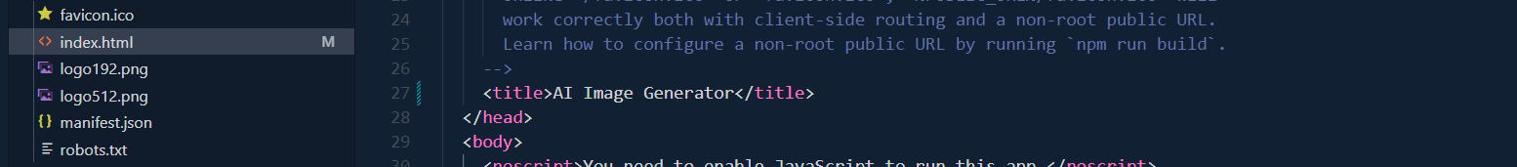

3.src teh Components naam e project create korbo then er bhitor 2 ta Folder create korbo

a.Assets b.ImageGenerator—jsx,css file creat korbo

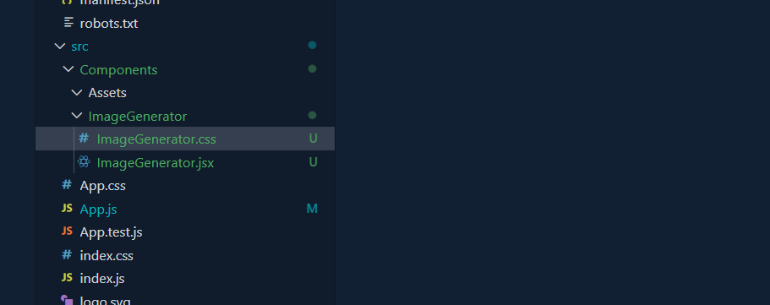

4. rafce lekhee click korle emon ready made code ashbe jsx e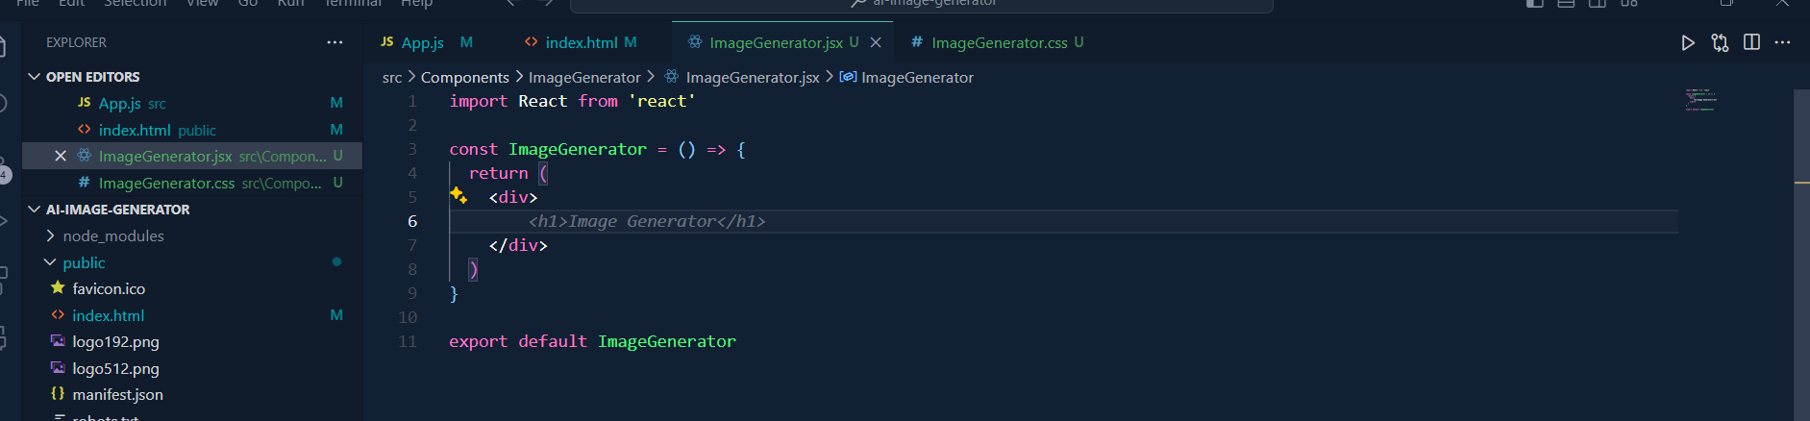

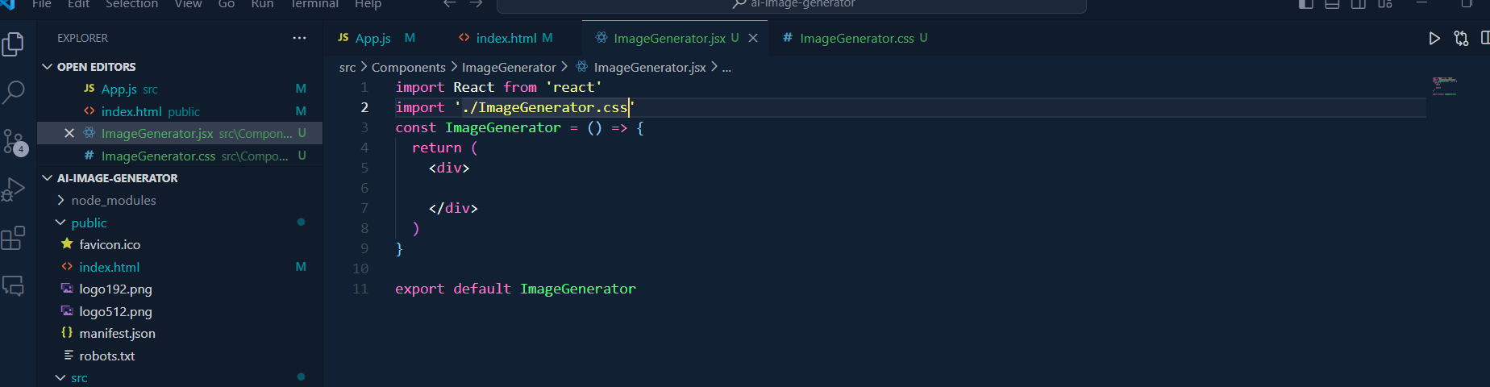

We have to import the file path of the css file in jsx

5.app.jsx e fille name die hbe within the div r auto import hoia jabe imagenerator

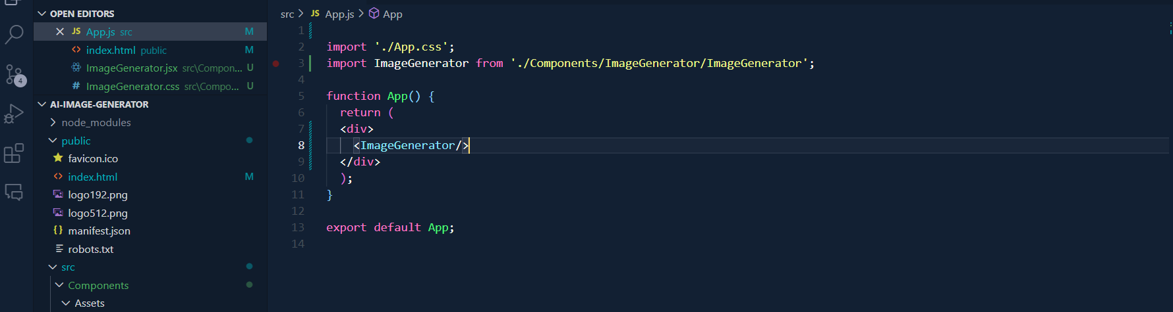

6.Components er assets e image rakhbo use korte

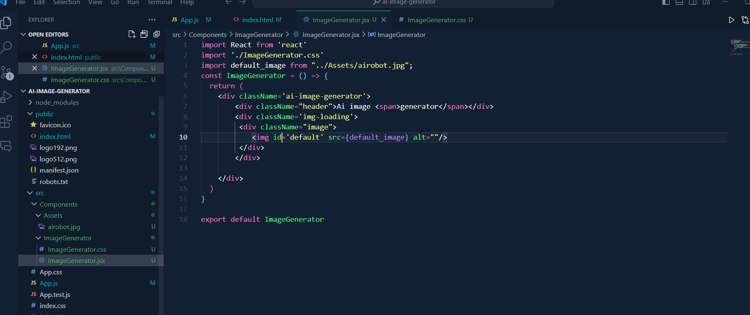

Import korbo jekono ekta var name from file location

Thn div er bhitor html er moto kore div diye shajabo

7.css file e nrml css er moto kore shajabo

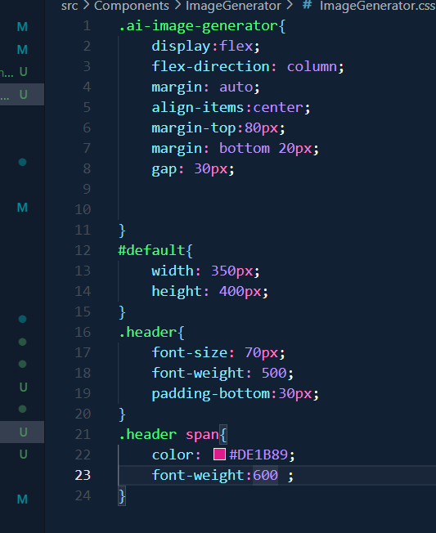  
index.css er body er bhitore background and text color change korbo

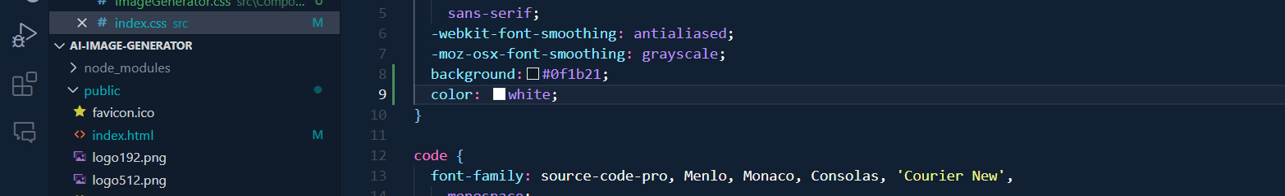

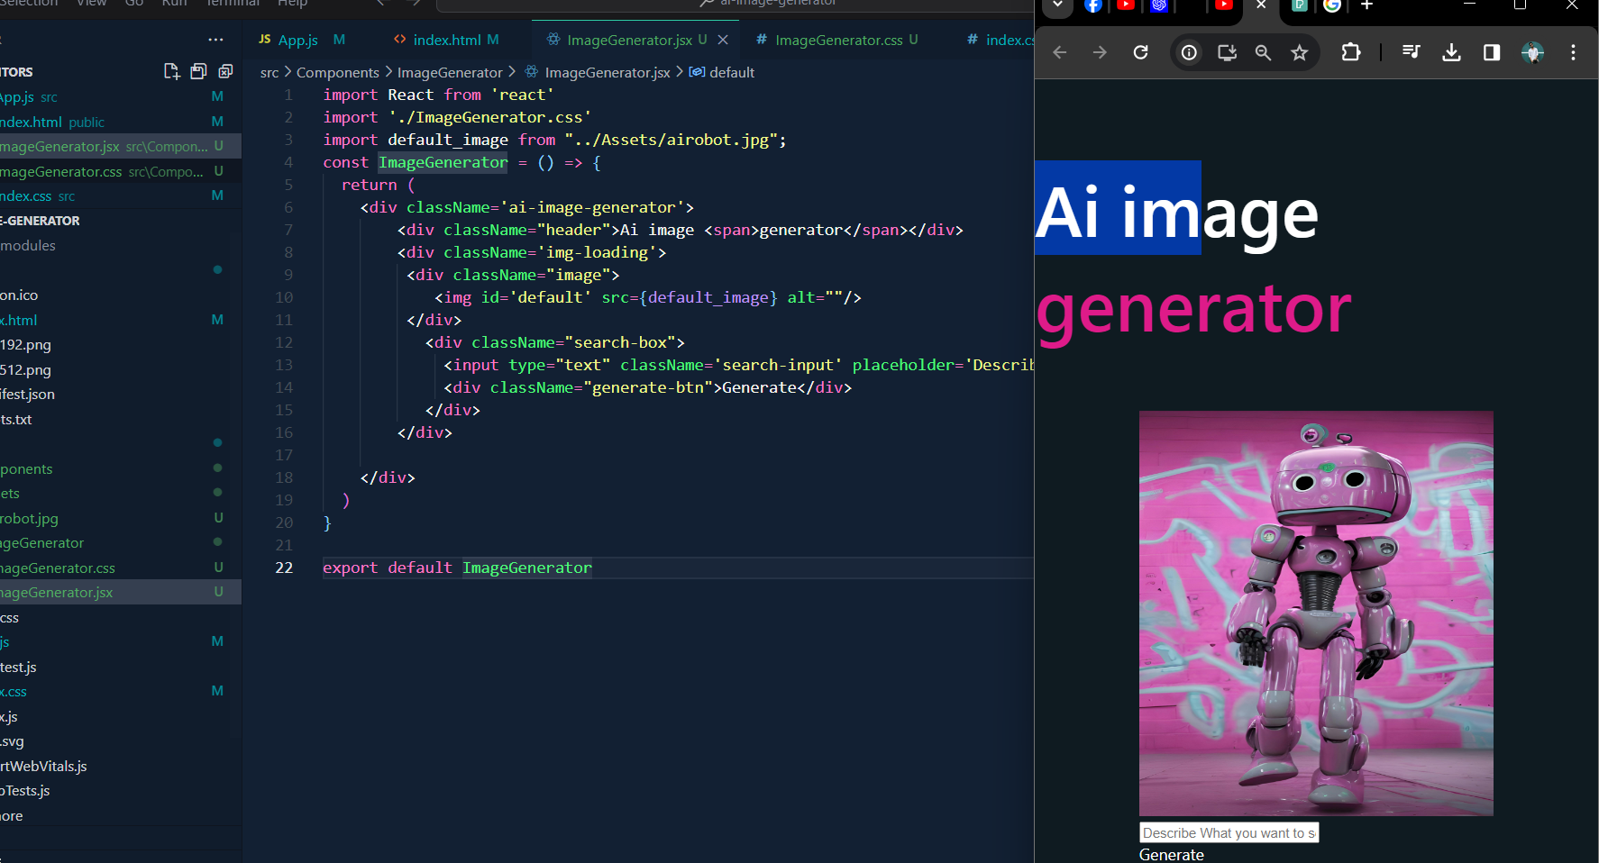

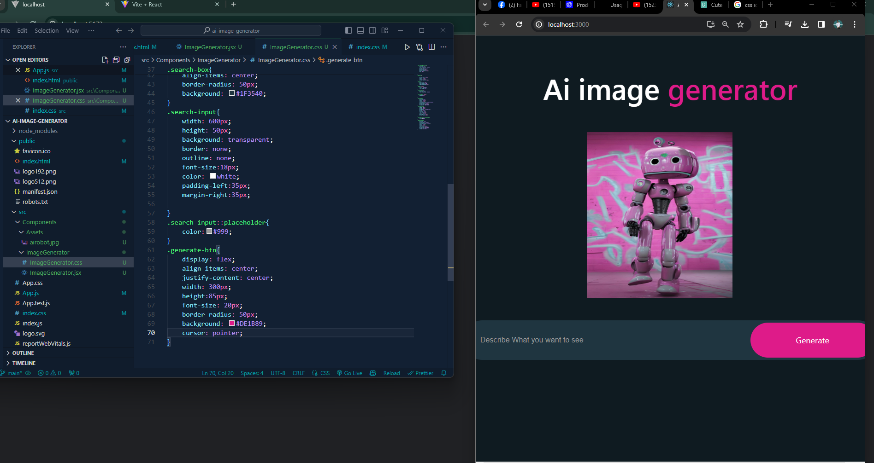

This is all about design

Now here we will do functionality

1.jsx file er return er upor image url set iage url usestate r input ref useref null dile suggestion e click korle auto import hbe

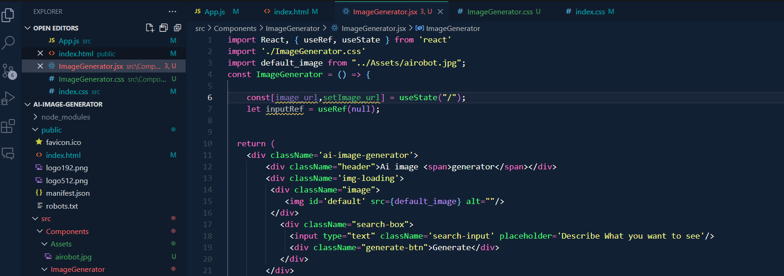

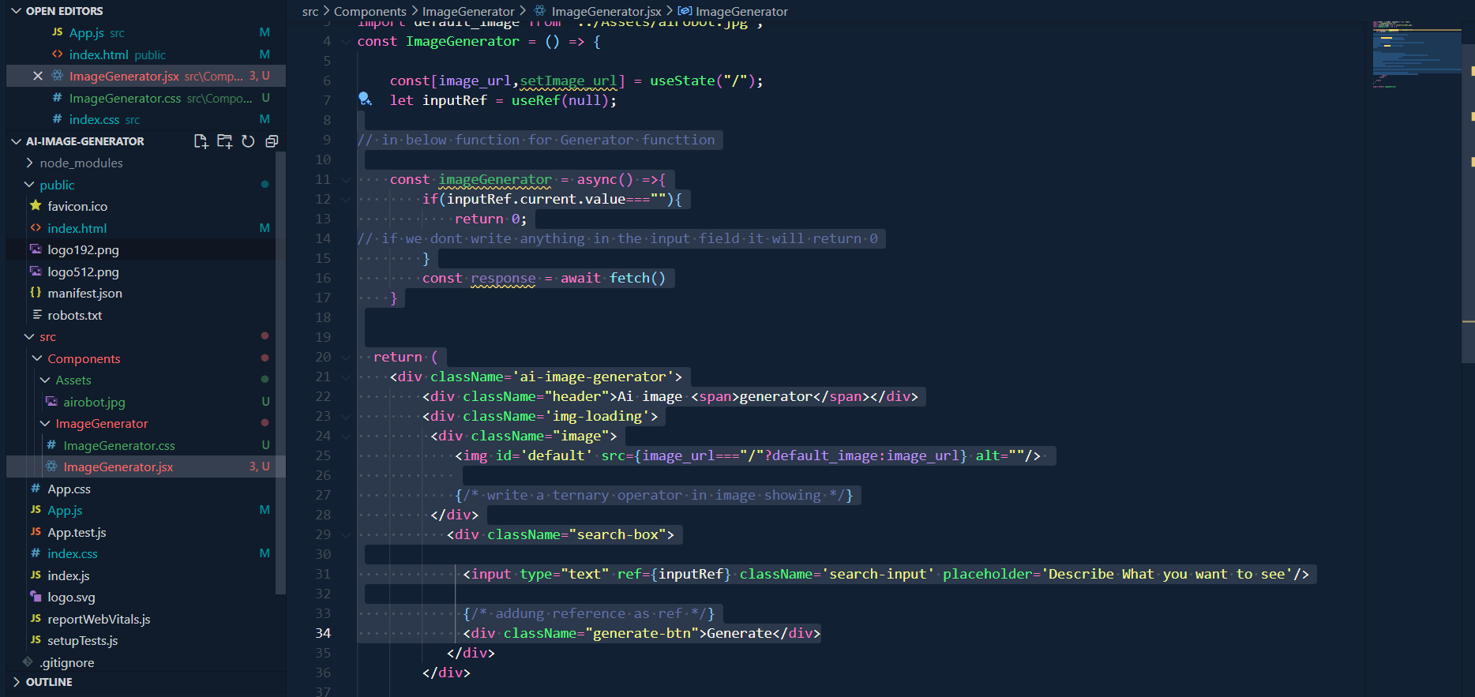

API link :OPENAI er website e jeye API e jabo

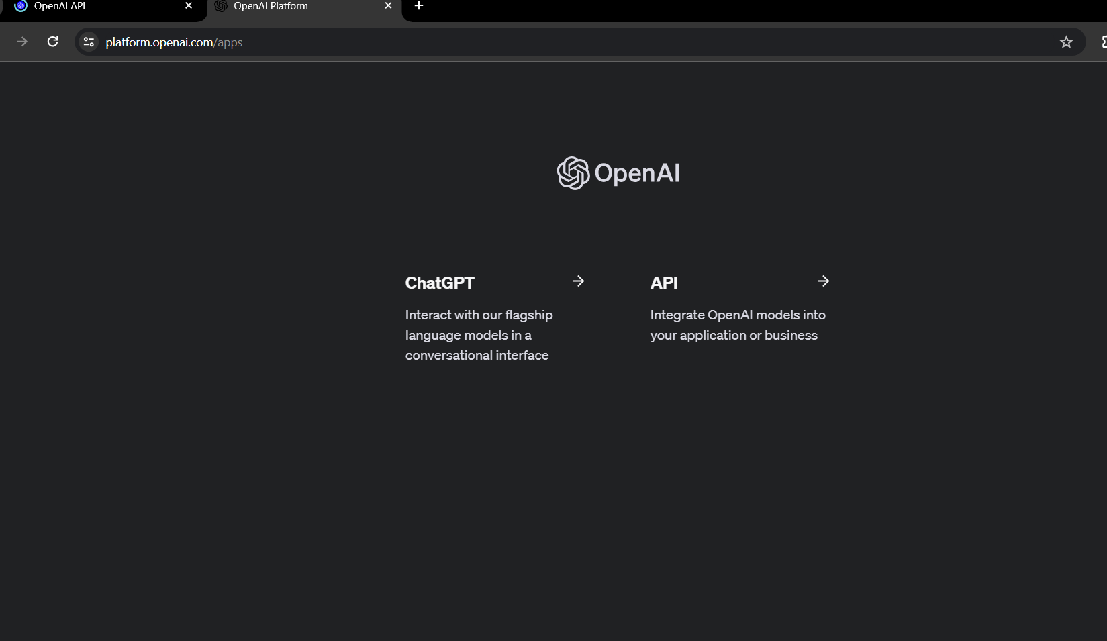

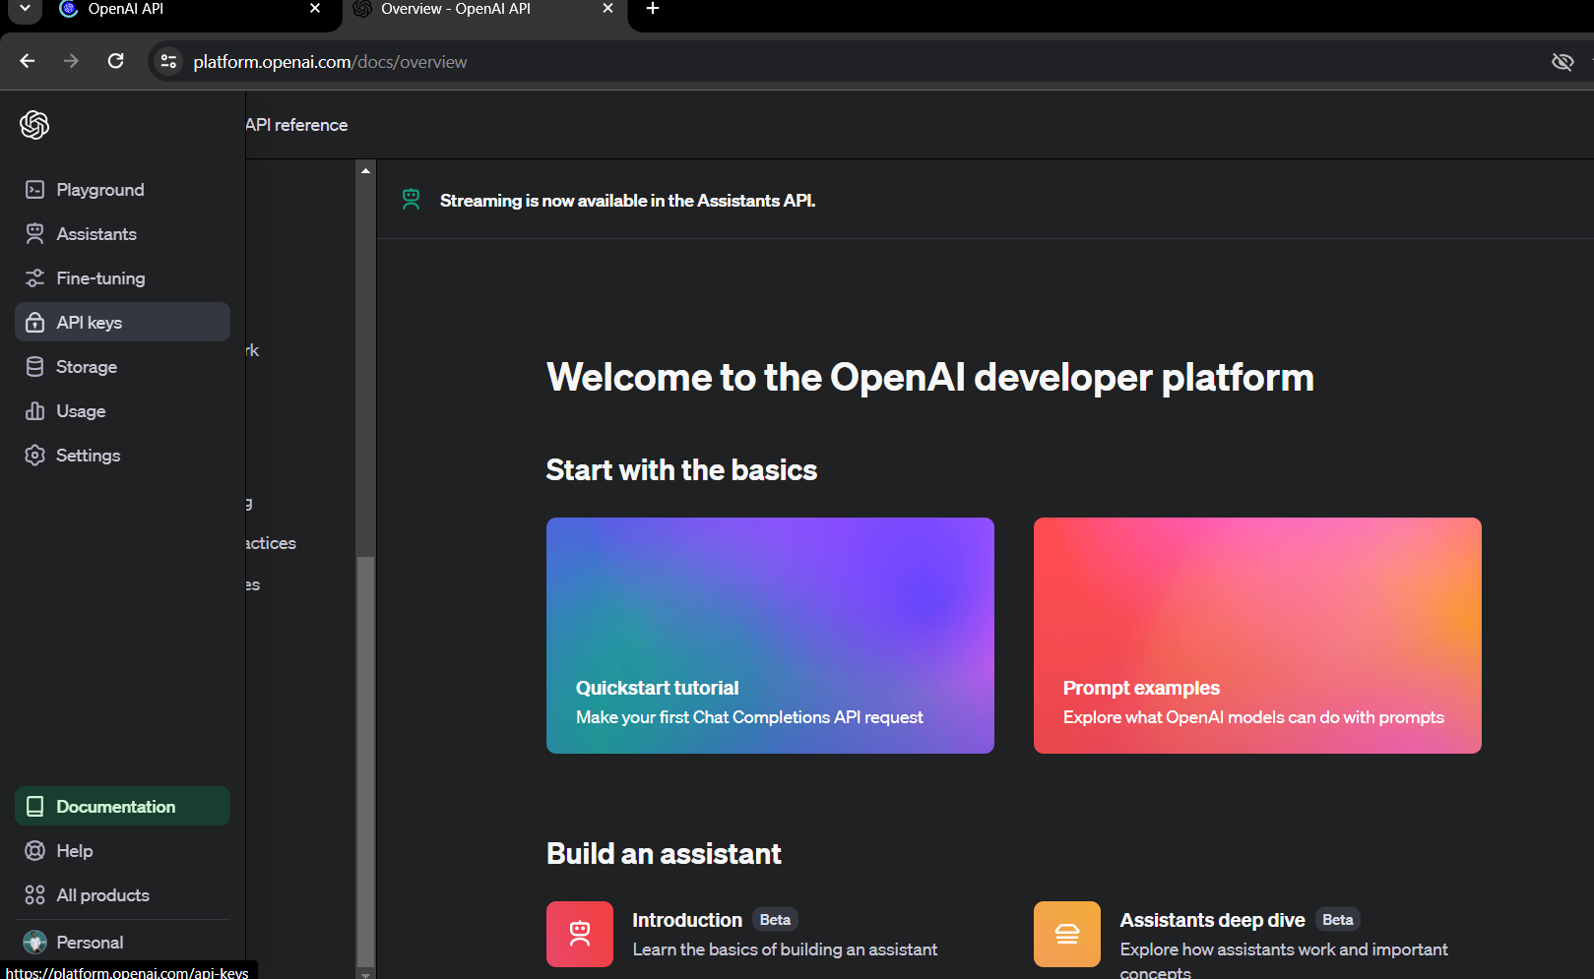

Then go to API keys

Create a secret key in any name and click that btn

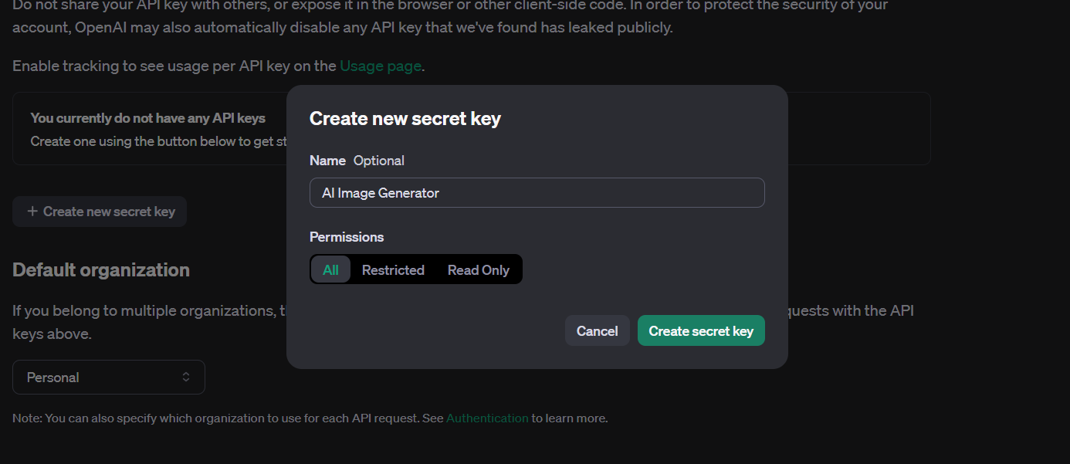

Copy the secret key in notepad cz it wont visible again

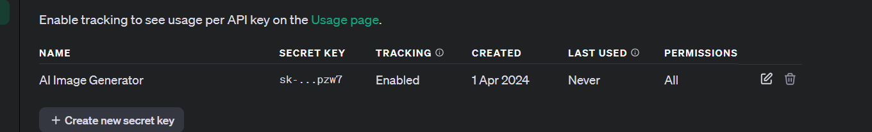

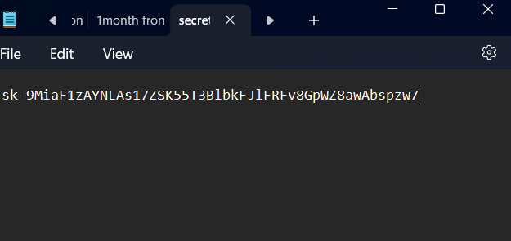

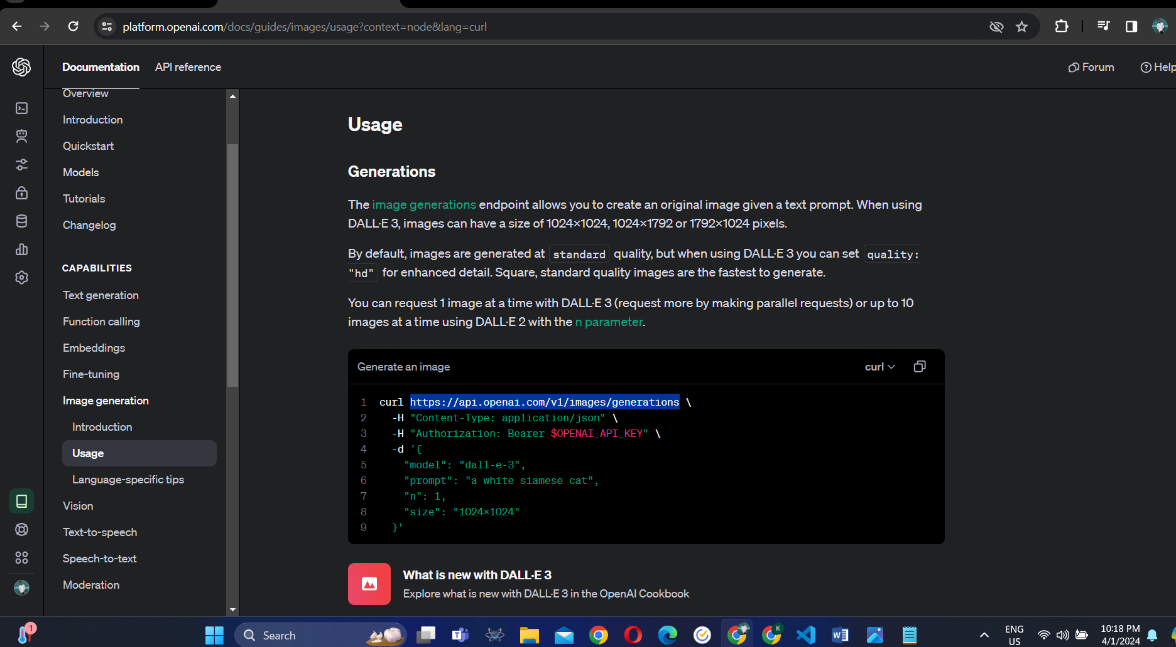

Documentation e jabo then curl er API url copy korbo

